Studying in
the United Kingdom and Ireland
Panamanian students

Reference manual elaborated by the Embassy of Panama in London

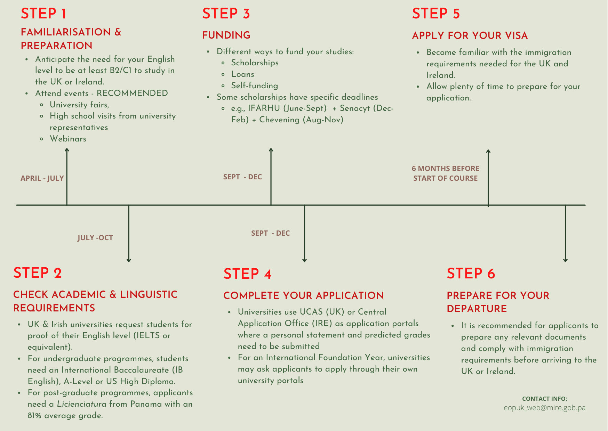

STEP 1 - familiarisation & preparation

- Opportunities to study in the United Kingdom (UK) and Ireland (IRE) are available to Panamanian high-school students. The familiarisation & preparation (step 1) are crucial steps to be taken for these opportunities to be exercised. These steps take place in April-July and are divided in three parts:

  - Online webinars: webinars may be organised in order to explain the process of studying in the UK and IRE; which would include live Q&A sessions, testimonials from previous success stories, tutorials on how to use UCAS, and so on.
  - University fairs: British and Irish universities may be represented in fairs; which in turn may be advertised to high-school, university students and professionals.
  - High-school visits: International recruiters from British and Irish universities may carry out visits to high-schools to support students in the understanding of their respective educational systems.

Advantages to study
in the UK (Annex A) | in IRE (Annex B)
1) High quality education and learning  2) Cultural diversity and development of excellent language skills  3) Quality of living and work opportunities | 1) Costs of education and living expenses  2) Quality of living, education and learning in one of the most innovative countries in the world  3) Easy visa entry process and stay back visa option.

STEP 2 - check academic and linguistic requirements

- While the familiarisation (step 1) is taking place, the student may start considering their decision toward studying either in the UK or IRE, the specific domain of study, and a variety of institutions where to do so. The next step in their decision is whether they meet the language requirements (step 2) asked by universities. Each university sets its own English requirements, usually CEFR level B2/C1, which are above the minimum level the UK Home Office requires (governing body that grants the student visas in the UK). You must have been awarded your test two years before the date of your application and it must be sat at an approved test location.

  - Universities in the UK usually ask an overall score of IELTS 6.5/7.5 or equivalent. The research findings comparing the English requirements of 43 universities in the UK and 13 in IRE is that the IELTS Academic is the most recognised and the second most accepted is the Pearson test. The LanguageCert or Trinity College London are usually accepted (please check on Annex 7). Cambridge and Oxford certificates are rarely accepted.
  - Universities in IRE usually ask an overall score of IELTS 6.0/6.5 or equivalent.
    - If you do not meet the English requirements and you have an IELTS of at least 5.0, the university might suggest pre-sessional English courses to improve your level for 6 to 10 weeks. The price may amount to £3,000 on average. Depending on the university, the successful completion of the pre-sessional English course is enough to make students start their undergraduate studies.
    - To prepare yourself for this English test, the compulsory 5 hours per week of the Panama educational system might not be sufficient. Students may need to consider during Premedia and the Bachiller / Media to attend additional English courses. In Panama, three foundations can help you improve your level of English: Buenos Vecinos, Superate JUDA and Instituto America.

- Simultaneously to meeting the language requirements asked by the universities (step 2) and undertaking the visa procedure with the UK Home Office or with IRE (step 4), students need to check whether they meet the universities' academic requirements (step 2).

  - To start undergraduate (UG) studies directly, Panamanian students must have the A-levels (UK educational system), the English International Baccalaureate (IB) or the US High Diploma (SAT - ACT - APs).
    - If students do not have any of the above qualifications and instead have the Panama Bachillerato, they will need to complete an International Foundation Year prior to beginning their undergraduate studies.
  - To start postgraduate (PG) studies directly, Panamanian students must have a Panama Licenciatura with an overall average 81-90% (=score of B ‘Bueno’, equivalent to a 2.1 UK), or 2.1 UK Bachelor degree, or GPA of 1.75-2.49 out of 3.0 (Grade Point Average – US Bachelor).
    - If they do not have the required grades, the university might suggest a pre-master course.

STEP 3 - funding

- As soon as students know the academic and linguistic requirements (step 2), they need to anticipate the budget to fund their studies (step 3), including the tuition fees, the transport, the accommodation, living expenses and so on.
  - In the UK, the international tuition fees are on average £11,000-30,000/year for undergraduate studies and £15,000-50,000/year for postgraduate studies.
    - Universities may offer funding for students through scholarships which may help reduce the tuition fees (Annex 2). It has been demonstrated that the more niche the scholarships’ domain is, the more extensive the financial coverage would be. Specific scholarships are usually aimed at STEM, Law, Humanities, the Arts, Business, and Maritimes studies.
    - IFARHU (Instituto para la Formación y Aprovechamiento de Recursos Humanos) in Panama provides loans and scholarships for Panamanian students for UG, PG, PhD, and English courses. The payment is either ‘al vencimiento’ (begins to be repaid once the student completes his studies) or ‘immediate amortisation’ (begins to be repaid after Term 1).
      - ‘Auxilios económicos’ is a financial aid designed to give students the money without subjecting them to go to a specific country. Usually, there is no return policy for ‘auxilios económicos’ intended for students willing to study a degree in a field of study not offered in Panama (e.g. Big data, biomedicine and so on).
      - Regular scholarships subject students to go to a specific country, and the directive board may design contracts with a clause stating a return policy or not. Usually the government requires students a 5-year stay/work in Panama after finishing their studies.
      - Loans can be repaid while in Panama or overseas.
    - SENACYT (Secretaría Nacional de Ciencia y Tecnología) is in collaboration with IFARHU and provides loans. All SENACYT aids require students to come back to Panama. If the student doesn’t comply, he must pay for the full amount granted.
    - Chevening is the UK’s government international scholarships programme supporting financially Masters / PhD students. It is funded by the Foreign, Commonwealth and Development Office (FCDO). It offers full scholarships covering one year of tuition fees. Specific eligibility criteria must be met.
  - In IRE, the international tuition fees are on average €9,850-22,250/year for Undergraduate and €9,950-35,000/year for Postgraduate.
    - Universities may offer funding for students through scholarships that may help reduce the costs of tuition fees. (Annex 2)

STEP 4 - complete your application

- Once steps 1 through steps 3 leads to a decision for the student to study in the UK or IRE; it is time to start the APPLICATION PROCESS (step 4).
  - To start your undergraduate studies in the UK, (if you can start them directly – IB, US High Diploma or A-levels), you apply up to 5 courses via UCAS. The one-off application fee is £26. The university may send the student either an unconditional or a conditional offer or reject the application.
  - To start your undergraduate studies in IRE, you need to apply via the Central Application office. You can apply up to 10 courses of Level 7 (Ordinary Bachelor Degree) or Level 8 (Honours Bachelor Degree). The application fees is €45.
  - To start your postgraduate studies in the UK or IRE, (if you are able to start them directly, having completed either a UK bachelor, US bachelor or Licenciatura - with specific grades), you may apply directly on the website of each institution. Each application costs £100 on average. The application period is from October to April.

STEP 5 - apply for your visa

- If the student meets the language requirements asked by the university, they may consider organising his/her journey to the institution in the UK or IRE and the ways to be granted a Student visa as a non-EEA/EU student (step 5).
  - In the UK, as a non-EEA/EU student, Panamanians need to be granted a Student Visa (Tier 4) to enter the country and need to start the procedure prior to traveling to the UK. It costs $363 and can take up to 8 weeks.
  - The UK Home Office asks students to prove their English level (CEFR level B1) with a Secure English Language Test (SELT) from an approved provider. You need the IELTS for UKVI or IELTS Life Skills (not provided in Panama anymore, the nearest test centre is in Colombia, Bogota), Pearson PTE Academic UKVI or PTE Home (provided by Universidad Santa María la Antigua), PSI Services Skills for English UKVI (provided by The U for You – Panama City), LanguageCert International ESOL SELT (provided by Panama City ELS Paitilla), or Trinity College London. As the test will be taken in Panama (which is outside the UK), the providers to pass the above SELT are: PSI Services, IELTS Consortium, LanguageCert, and Pearson (not Trinity College London).
    - The U for You and Experiencias Overseas are educational consultancies helping students to choose their university and guiding them through the entire application process based on their expectations and needs. They offer their services for FREE within their network of university partners.
  - In IRE, as a non-EEA/EU student, Panamanians do NOT need a Student Visa to enter the country, a 90-day-stay is allowed without a visa. If you wish to stay longer, you must book an appointment at the Irish immigration office to be granted the Ireland Permanent Residency. It is recommended to book this appointment prior to travelling to IRE. Otherwise, if you try to book an appointment as soon as you arrive in IRE, there is a risk that the immigration office could not have any availability within a 3-month period. In that case, you will have to stay in IRE as long as your passport has not been stamped.

STEP 6 - prepare for your departure

- Make travel arrangements:
  - Students should confirm with their educational institution (university) when they are expected to arrive, in order to make the necessary travel arrangements. Arrival date should also comply with any visa regulations. Other key issues should be solved as well, such as making sure health insurance, university accommodation and visa are all set.
  - Once these have all been organised and the student is aware of the arrival date on campus, travel arrangements can be finalised (e.g., airfare and other transport).

- Gather any relevant documents for arrival:
  - The day before departure, it is best to make sure all necessary documents are set and organised. Relevant documents may include those that need to be shown at customs/border in the airport. These include, but are not limited to: valid passport, visa, proof of residency or proof of your studies, and financial support.

TIMELINE

- The timeline has been divided in two parts, depending on the educational system the students have followed.
  - If students have the Panama Bachillerato, and thus cannot enter directly an undergraduate in the UK, they have to start with a Foundation Year or pre-sessional English course. They will need a SELT approved by the UK Home Office to be granted a Student Visa (Tier 4) and at least IELTS score of 4.5, with no single element less than 4.0.
    - During Academic Year 11th, students have to start passing their English tests.
    - During Academic Year 12th, students will start the familiarisation & preparation (step 1) during the first two semesters (March – July). They will have to take a decision (step 4) regarding where and what to study by August in order to start applying for scholarships (IFARHU, June-September; and Senacyt, December-February) and for the International Foundation Year to the universities directly (September – November). Students will receive their offers by December while passing at the same time their final exams (Bachillerato). Then, two scenarios are possible:
    - 6-month prior to starting UG studies: if you meet the Foundation Year requirements, you can start your UG in September the year after. Foundation programmes can be generic or designed to prepare the student for starting a degree in a certain field of study. They are usually one year long, but universities are flexible and can propose 6-month intensive track (from January to August).
    - one year and a half prior to starting UG studies: if you do not meet the Foundation Year requirements and have no formal English qualifications, the university may suggest Pre-sessional English courses (for 6 weeks up to 16 weeks) prior to entering onto the Foundation year; and then a Standard One-year long International Foundation Year; and starting the UG. Fees range for the Foundation Year are from £2,200 and 22,000 per year and the pre-sessional English course, from £3,000 up to £5,000.
  - If students have an English IB, A-level, or US high Diploma, they can enter directly an UG in the UK (or students in their penultimate year of Panama Licenciatura who can enter directly postgraduate studies in the UK).
    - During Academic Year 12th, they must pass in March an SELT approved by the UK Home Office to be granted a Student (Tier 4) Visa. Then, students may start the familiarisation & preparation (step 1) during the first two semesters (April – July). They might take a decision (step 4) regarding where and what to study by August in order to start applying for scholarships (IFARHU, June-September and Senacyt, December-Februrary).
    - Then, the period to apply to 5 courses via UCAS is the following in chronological order: Oxford, Cambridge, and most courses in medicine, dentistry, and veterinary (May – 15th October) and most of the UG (May - 26th January). Students will pass their final exams and start receiving universities’ offers by February/March. They have a 6-month gap from January to August to prepare their journey to the UK and start their UG mid-September.

Annex A: Advantages to study in the UK

- High quality education and learning
- UK universities are known for aiding students to refine their critical and creative thinking skills and equipping them with skills and experiences that will help them succeed in the professional world, regardless of their career choice.
- The UK offers specialised degrees at universities both for undergraduate and postgraduate (research and/or taught). It is ideal for students who do not wish to wait until the postgraduate level before specialising in a specific area of study.
- UK universities are inspected regularly by the Quality Assurance Agency for Higher Education to ensure that they maintain the high standards of learning which are expected. As a student, you will get the opportunity to be taught by the world’s leading academics and to develop skills and confidence.
- According to QS World University Rankings 2022, Oxford, Cambridge, Imperial and UCL rank second, fourth, seventh and eighth place (respectively) among the top 10 universities in the world.

- Cultural diversity and development of excellent language skills
- The English Language is predominant within the global business arena; this, mastering the language is of crucial importance. By studying in the UK, students can immerse themselves and learn to live, work and think in English, which can ultimately enhance their employment prospects.
- The UK is a multicultural country, with over 500,000 international students, you can immerse yourself and learn about different cultures whilst studying.

- Quality of living and work opportunities
- According to the UK Home Office, an international student in the UK is typically allowed to work up to 20 hours a week during term time, and full-time outside of term time. This will enable you to gain valuable work experience, meet new people and earn money alongside your studies.
- A new Graduate Route scheme will also be available to anyone completing a UK degree from the summer of 2021. This will allow you to stay and work in the UK for up to two years after you graduate.
- UK degrees take 3 or 4 years to complete depending on where you study in the UK. Degrees from Wales generally take 3 years and from Scotland, they take 4 years. However Scottish students who are domiciled in Scotland and attend a Scottish university have their fees paid. A postgraduate degree takes only one year. This means you will spend less on tuition fees. On top of that, many scholarships, grants, and bursaries are available from institutions and universities.
- Living costs are also much lower in the UK compared to other countries around the world, such as the USA. Additionally, there is a significant number of discounts available to students.

Annex B: Advantages to study in IRE

- Costs of education and living expenses
- International tuition fees in IRE are on average €9,850-22,250/year for Undergraduate studies and €9,950-35,000/year for Postgraduate studies; which is significantly more economical than in the USA or in the UK.

- Quality of living, education and learning in one of the most innovative countries in the world
- IRE has a very high standard of education and teaching (e.g. Irish students are ranked 4th in the OECD 2019 Education report according to the criteria of the standard of education).
- Universities in IRE are in the top 3% worldwide (QSH ranking 2020), such as UCD, Trinity College, and Galway's college. Courses consist of independent work as in the UK; leaving time for professional opportunities and social commitment to societies.
- International students can join research programmes driving innovation and changing lives worldwide. IRE is one of the most innovative countries (16th in the world); a very entrepreneurial country with connections around the world (list compiled by MIT Technology Review Insights and IT consultancy business Infosys Cobalt).
- IRE is also home to five of Forbes Top 10 companies: Apple, Google, Alphabet, Amazon and Samsung. Students can take advantage of the stay-back visa option and aspire to work for organisations such as these. IRE meets the needs of a competitive economy and allow the transfer of knowledge between universities and international companies. IRE is good for careers in Software Development and IT, Engineering, Financial Services, Food and Agriculture, Medtech and Pharma.
- IRE has an appealing quality of life with its many historical places to visit, picturesque countryside, and vibrant cities (easily connected to the UK or Europe). As such, IRE is ranked 4th in the World Happiness Index for 2018.

- Easy entry to IRE without a visa and stay back visa option for graduates willing to start a career.
- Panamanians do not need a visa to enter the country and do not need to meet the linguistic requirements the Home Office requests in the UK.
- The stay-back visa option is open to Graduate students (for one year) and Master students (up to 2 years) to start a career in IRE.
- The option to combine a student visa and a working visa (green card) is open to Panamanians, allowing them to carry out a part-time job to help fund their studies (stamp 1G).

